Get ready to Rally!

22nd & 23rd June 2024

Risby Village Hall,
Bury St Edmunds, IP28 6RT

Hosted by Lucy Dawson

Open to all TD Rally® registered dogs!

All levels including L3+!!

Entries Close: 25th May 2024 (Postmarked)

Contact Information

Trial Secretary: Lucy Dawson
Tel: 01359 240676 Email: lucy@luphen.co.uk

Entries and Closing Dates
Entries will be accepted from now. Entries close and must be postmarked by 25th May 2024. Entries received after this date will not be included. All entries are taken on a first-come first-served basis. Running orders will be emailed; they will not be posted unless an SAE is received with the entry.

Venue Address
Risby Village Hall, Aylmer Close, Bury St Edmunds, IP28 6RT.

Check-In and Walk-through Times (approx at present)
Doors open and check in starts at 8.30am. Walk throughs will commence 15 minutes before each class.

Saturday Ring One:

Judge – Jacky Ruddock:
Veteran L3 – walk through 8.45am
Level 3 – following on
Level 3+ - following on
PL2 / PVL2 – NOT BEFORE 10.00am
VL2 / Level 2 – following on

Puppy / Veteran L1 – NOT BEFORE 1.00pm
Level 1 – following on

Saturday Ring Two:

Judge – Jacky Burden

PL2 / PVL2 / VL2 – walk through 9.00am
Puppy / Veteran L1 – NOT BEFORE 10.00am
Level 1 – following on

Judge – Tanya Butler

Level 2 – NOT BEFORE 12.30pm
Veteran L3 / Level 3 – following on
Level 3+ – following on

Sunday Ring One:

Judge – Tanya Butler
Veteran L3 – walk through 9.00am
Level 3 – following on
Level 3+ - following on
PL2 / PVL2 – NOT BEFORE 10.00am
VL2 / Level 2 – following on

Judge – Jacky Burden
Puppy / Veteran L1 – NOT BEFORE 1.00pm
Level 1 – following on

Sunday Ring Two:

Judge – Sue Coulstock

Puppy / Veteran L1 – walk through 9.00am
Level 1 – following on
PL2 / PVL2 – NOT BEFORE 10.30am
VL2 / Level 2 – following on

Judge – Jacky Ruddock

Veteran L3 / Level 3 – NOT BEFORE 1.00pm
Level 3+ – following on

TD Rally® Entry Form (please print clearly)
Competitor's Details:
TD Rally® Team Registration Number:
First & Last Name
Address
Town/City
Postcode
Tel
Email
(running orders will be emailed unless an SAE is received with the entry)
Dog's Details
Name
Breed
Sex |  |  | DOB
Trial Entries (tick boxes that apply)
Day | Ring | Puppy | VL1 | L1 | PL2 | L2 | PVL2 | VL2 | L3 | VL3 | L3+
Sat | One
 | Two
Sun | One
 | Two

NB. A team may enter a maximum of 2 classes on each day; they may however be the same level, eg 2 x Level 1.

Could your team title at this trial? Y / N
If so please state which level, which award or title and how many Qualifying scores are needed; 1 or 2, eg ‘PL2 champ, 2 Qualifying scores’

…………………………………….
Fees: £6.00 per class per team

Send entry form with cheques payable to Lucy Dawson:
TD Rally® Trial Secretary
Lucy Dawson, 23 Wrights Way, Woolpit, Bury St Edmunds IP30 9TY

Or pay by Bank Transfer (state your name on the narrative):
Account Name Lucy Dawson
Sort code 60-83-71 Account Number 60210249

DOGS IN CARS ON HOT DAYS
Lucy Dawson and Talking Dogs Rally® take animal welfare seriously. While at a sanctioned TD Rally® event, competitors and spectators should take their dog’s health and welfare into account before leaving them in a car.

WARNING: DOGS WILL BE REMOVED FROM A HOT CAR IF FOUND IN DISTRESS OR AT RISK WITHOUT LIABILITY TO LUCY DAWSON OR TD RALLY®.

SCOOP THE POOP!
There is still a lot of anti-dog feeling around. Many halls will not accept dogs, so please help us keep this hall and recreation area and dispel the fears of the anti-dog lobby by picking up after your dog. Please do not allow your dog to dig or damage the recreation area.

Vet On Call

Hawkedon Veterinary Surgery
Rede Road
Hawkedon
Bury St Edmunds
Suffolk
IP29 4NP

01284 789428

DELICIOUS HOT FOOD

AND DRINK AVAILABLE!!

Directions to venue
From A14

Come off the A14 at Junction 41 signposted for Risby.
(a) If coming from WEST, continue along Newmarket Road for ¾ mile, turn left onto South Street signposted Risby (sign may be hidden in hedge!). Be careful not to continue back onto A14.
(b) If coming from EAST, follow slip road and at Give Way signs, turn right signposted Risby. Follow road looping over A14. Turn right at end of road (signposted Risby) onto South Street.
Turn right after 1/3 mile into School Road.
Turn right into Aylmer Close, follow small signpost for Village Hall.

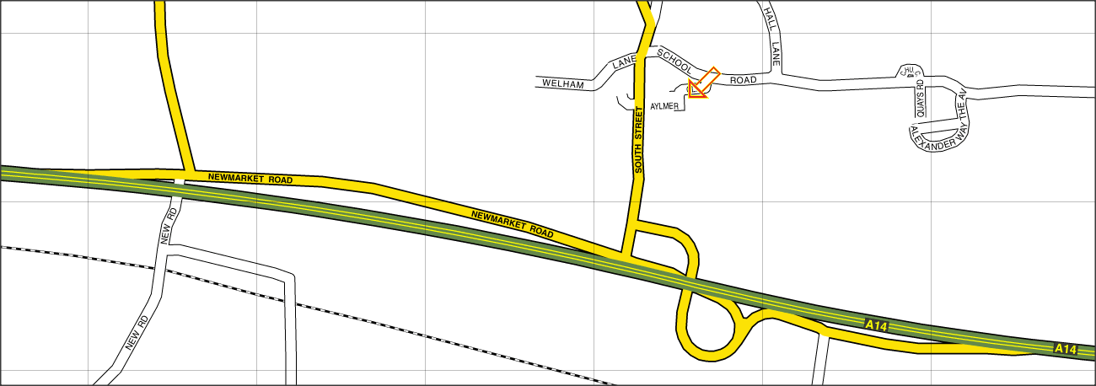

TD Rally® eligibility

All competitors must be registered with TD Rally® prior to competing at any sanctioned TD Rally® trial. To register, contact the Office or go to the website and download the form and send it with payment to the TD Rally® office.
Everyone over the age of 7 years (when attending trials children under 16 years old must be accompanied by a parent or guardian) on the date of the trial is eligible to compete once registered with TD Rally®.
All breeds of dogs, crosses and mixes of breeds over 6 months old on the date of the trial can compete. Health and behaviour may exclude dogs from competing but breed type does not.

Competing Levels

Puppy is for dogs aged between 6 and 18 months on the date of the trial.

Level 1 is for dogs 1 year and older on the date of the trial. This level is for the experienced or professional handlers, trainers, apprentice or qualified judges, those who have already won a TD Rally® Level 1 Title or a Title in any other dog sport.

Pre Level 2 is for dogs 1 year and older on the date of the trial. This level is for handlers who have already won a TD Rally® Level 1 Title or Championship.

Level 2 is for dogs 1 year and older on the date of the trial. This level is for handlers who have already won a TD Rally® Level 1 Title or Championship.

Level 3 is for dogs 1 year and older on the date of the trial. This level is for handlers who have already won a TD Rally® Level 2 Title or Championship.

Level 3+ is for dogs 1 year and older on the date of the trial. This level is for handlers who have already won a TD Rally® Level 3 Title or Championship.

Veteran Level 1 is for dogs over 7 years on the date of the trial.

Pre Veteran Level 2 is for dogs 7 years and older on the date of the trial. This level is for handlers who have already won a TD Rally® Level 1 Title or Championship.

Veteran Level 2 is for dogs 7 years and older on the date of the trial. This level is for handlers who have already won a TD Rally® Level 1 Title or Championship.

Veteran Level 3 is for dogs 7 years and older on the date of the trial. This level is for handlers who have already won a TD Rally® Level 2 Title or Championship

Terms & Conditions

- Each team, a team consisting of one dog and one handler, must hold a valid Talking Dogs Rally® (TD Rally®) registration. Teams with disabilities must have submitted a Disability Modification Form to the Talking Dogs Rally® Office prior to the Trial or along with their Trial application form. Disability Modification Forms will not be accepted on the day of the Trial.

- No unregistered substitutions for handler or dog are permitted.

- The Trial will be held outdoors on grass.

- By entering this Trial, competitors acknowledge and agree to abide by the rules, terms and conditions as laid out by Lucy Dawson and Talking Dogs Rally®.

- The Trial hosts reserve the right to refuse any entry for any reason. Refunds cannot be guaranteed for entries withdrawn or dismissed for any reason but may be given depending on circumstances. If the Trial has to be cancelled for any reason we will refund entry fees if possible but this is not guaranteed. If the trial host cancels the trial, the trial host will refund all trial fees in full to registered competitors within 14 days of the trial date. If Talking Dogs Rally® cancels the trial, the trial host will refund all trial fees in full to registered competitors within 14 days of the trial date.

- The Judge’s decision is final; rudeness to judges will not be tolerated.

- Returned cheques do not constitute a valid entry.

- Your team may not compete if your bitch comes into season immediately prior to or during the Trial. Do not bring your dog to the Trial if s/he is ill or injured, or has been infected with, or has been in contact with another dog infected with, a contagious disease.

- If your pet is ill or suffers an injury during the Trial, please notify the Trial Organisers.

- Competing in Talking Dogs Rally® is a physical activity and as such Handlers are reminded to work with due care and attention to their own safety and that of others. Handlers are responsible for the conduct of their dog at all times. Neither Talking Dogs Ltd, Talking Dogs Rally® or any person acting on behalf of the Company accept any liability for any loss, damage, accident, injury or illness to dogs, handlers, spectators or any other persons or property whatsoever.

- Photographs and/or recordings may be taken by and on behalf of the Trial hosts for educational and publicity purposes. All other photographs and/or recordings may be taken for personal use only. All video and broadcast rights for this Trial are the exclusive property of Talking Dogs Ltd.

- Dogs must be kept on lead when not competing.

